**Getting Started.**

You need create a Firebase Project and Enable Email/Password authentication in firebase.google.com

1. Install your Ionic CLI.

Please make sure latest Node 6 LTS and NPM 3+ are installed.

Then, install the CLI globally (you may need sudo):

$ npm install -g ionic@latest

You can verify your installation with the ionic --version command.

1. Download and uncompress your Files.

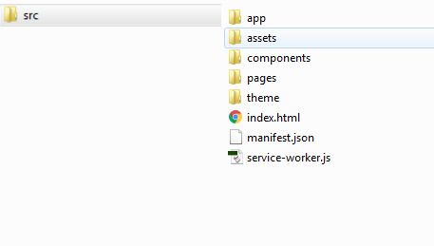

1. Create your project with [Ionic CLI](http://ionicframework.com/docs/v2/getting-started/installation/).

Start a new Ionic project using ionic start

$ ionic start myNewProject blank

1. Go to your Project.

$ cd ./myNewProject

1. Add this packages to your project.

npm install @ionic/app-scripts@latest --save-dev  
 **npm i angularfire2**

1. Replace your src folder for the files that did you download and uncompress.
2. Go to file src/app/app.component.js and update the info with your firebase data.

var CREDENTIALS = {

  Key: "<API_KEY>",  
    authDomain: "<PROJECT_ID>.firebaseapp.com",  
    databaseURL: "https://<DATABASE_NAME>.firebaseio.com",  
    projectId: "<PROJECT_ID>",  
    storageBucket: "<BUCKET>.appspot.com",  
    messagingSenderId: "<SENDER_ID>",

};

1. Run

$ ionic serve